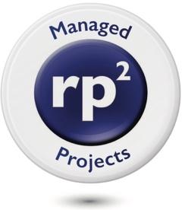

STEVE HALL

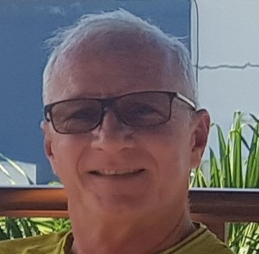
Steve Hall is a Director of Relentless Pursuit of Perfection Managed Projects (rp² MP), a drilling project management company that provides fully integrated wells teams to small and mid-sized operators.
The service is an excellent option for those who need a professionally managed project, but do not have the in-house resources required to do so.

Steve graduated with a degree in Chemical Engineering from University of Waterloo, Canada and is a Professional Engineer and a member of the Society of Petroleum Engineers (SPE).
He joined Gulf Canada as a Wellsite Supervisor and later Drilling Engineer. He managed multi-rig projects in remote areas in north east British Columbia as well as deep foothills wells in Alberta. In 1993, he joined Bow Valley Indonesia as a Senior Drilling Engineer in Tanjung, South Kalimantan and later in South Sumatra.
Moving to New Zealand in the late 90’s, he planned and drilled Fletcher Challenger Energy’s first two offshore wells and prepared the FDP for the Pohokura gas field.
Landing in Oman in late 2001, Steve worked as an Asset Drilling Engineer for the Qarn Alam field, overseeing drilling for the field that had 4 full time rigs and 120,000 BOPD production. He also worked as a DTL (Delivering the Limit) Engineer for PDO, optimizing well designs for numerous major fields across Oman.
After working for several multi-national oil companies in Oman, he joined CCED as Drilling Manager in 2010 to start their appraisal/development program, which saw production grow from zero to 6500 BOPD within the first year.
Since returning to Indonesia, Steve has managed several offshore projects for Mubadala and Conrad Petroleum as well as Cue Energy.
For Conrad and Cue, Steve sourced, interviewed and hired the entire wells teams: Drilling Engineering & Well-testing, HSE, Procurement, Logistics and Wellsite Teams.
In total, he has drilled over 40 wells in Indonesia.
He has also provided project assurance on several projects throughout South East Asia.
Steve is based in Jakarta, Indonesia.
Steve can be contacted on +62 811 995 1898 and email steve.hall@rp-squared.com
Company websites:
www.rp-squared.com

