The Challenges Faced and the Successes Achieved in Delivering Well Operations Crew Resource Management in a Multi-Cultural Offshore Environment

Phil Smith and Gareth Lock, Critical Team Performance

Abstract

Since the disastrous events of the 70’s and 80’s, the international aviation community have worked together to develop, deploy and mandate crew resource management (CRM) training for aircrews, groundcrew and ATC. Unfortunately, it took a number of major incidents in the Oil and Gas sector to raise the visibility of CRM training despite numerous papers being written to this effect. Furthermore, until the OGP/IOGP commissioned two policy and operational documents - Doc 501 (Syllabus for CRM for Well Operations Teams) and Doc 502 (Guidelines for Implementing Well Operations CRM training), there was no clear direction on what Well Operations CRM (WOCRM) was and how it should be deployed.

In late 2014, Critical Team Performance started a training intervention of sixteen 10-day training & coaching WOCRM sessions, specifically focusing on supervisors using IOGP Doc 502 as the basis for course content. These sessions took place over an 8-month period with 1 Operator, 4 drilling rigs, 3 drilling companies and 16 shifts from a multitude of nationalities, cultures and experience. Most research examining WOCRM has been carried out in single cultural environments e.g. the North Sea where there are few barriers to communication and learning. This paper will highlight the challenges faced and successes won when delivering training to more than 20 nationalities, with roles from rig superintendent, through DSV and OIM, to the ACOs and ADs, and where English was not the first language for most participants.

Introduction

The Association of Oil and Gas Producers (OGP) published report 460 (OGP, 2012) on the cognitive issues relating to process safety and made four recommendations concerning training in relevant non-technical skills (NTS), methods for challenging safety-critical decisions and maintaining real-time awareness and sensitivity to weak signals, and proposing that organisations should be able to demonstrate that safety-critical human barriers will actually work.

The OGP Well Expert Committee and the OGP Human Factors Sub-Committee then commissioned two further reports: OGP Report 501 (OGP, 2013) on ‘Recommendations for the Implementation of Crew Resource Management for Well Operations Teams’ and IOGP Report 502 (IOGP, 2014) that proposed ‘Guidelines for Implementing Well Operations Crew Resource Management Training’. In addition, the UK Energy Institute (EI) published its own guidance on a particular form of NTS training, namely Crew Resource Management (CRM), that made the case for such training based on the experience in other high hazard industries, such as aviation, rail, nuclear and mining (Energy Institute, 2014).

The North Sea Offshore Authorities Forum (NSOAF) also carried out a joint human and organisational survey of the factors relating to well control preparedness (NSOAF, 2013)

The HSE (1999) has defined human factors as the “environmental, organisational and job factors, and human and individual characteristics which influence behaviour at work in a way which can affect health and safety”. Given that they transcend national, cultural and organisational levels, any intervention needs to take this in to account and not just focus on the ‘sharp end’ but throughout the organisation.

The target audience for a Well Operations Crew Resource Management (WOCRM) intervention needs to include senior leadership (see greyed section of Table 1, Report 502). However, the most effective area for an intervention must be at the local supervisory level (Autrey, 2015) as this achieves two key aims; firstly, local supervisors have direct access to control and influence workers through their role as a leader, task manager and champion (Catchpole et al, 2010). Secondly, and maybe more importantly, they have the ability to change behaviours by acting as role models by demonstrating effective WOCRM skills. The World Health Organisation (WHO) Safer Surgical Checklist study (Haynes et al, 2009) identified, in hospitals across the globe, that to truly effect a change of behaviour, engagement and empowerment at the local level e.g. theatre nurses was essential and only after this happened was the effectiveness of the WHO checklist to improve patient safety realized. In her book, “Join the Club”, Rosenburg (Rosenburg, 2012) showed that positive peer pressure can achieve change where legislation and direct action have failed, especially when culture and social pressures are involved. Given the cultural heritage of the oil and gas industry, behavioural change is not simple and cannot be forced upon people, even if those in supervisory positions say that safe behaviour is the right thing to do.

The authors recognised, given their experience across multiple domains such as high threat bomb disposal & search and medical care, and the novel nature of the subject combined with the diverse cultures and nationalities within the target audience, there was a likelihood that retained knowledge would be low. Therefore, the training as described within IOGP Report 502 was extended to include an offshore coaching intervention to consolidate learning.
However, as with any commercial project there is a fine balance between the ideal training solution and the delivered effect due to target audience availability, training system resource and company financial resource. Therefore there was a need to show a return of investment to the prime operator; the authors decided to use the Kirkpatrick (Kirkpatrick, 1976) training evaluation model to achieve this. This model delineates four levels of training outcomes: reaction, learning, behaviour, and results. Salas (Salas, 2006) used this model during a review of CRM training in an offshore environment.

The aim for this programme was to achieve at least level 2 (learning) and in some cases, depending on the individual supervisors, level 3 (behaviour). Each trainee was given a simple baseline quiz at the start of day 1 and then reassessed at the end of the coaching sessions. However, there was evidence of ‘box ticking’ identified through the over-scoring of assertion skills (see Figure 1) compared to real behaviours, and also because some of the Likert scales had been reversed to capture situations where the attendees would run straight down the boxes ticking the top score.

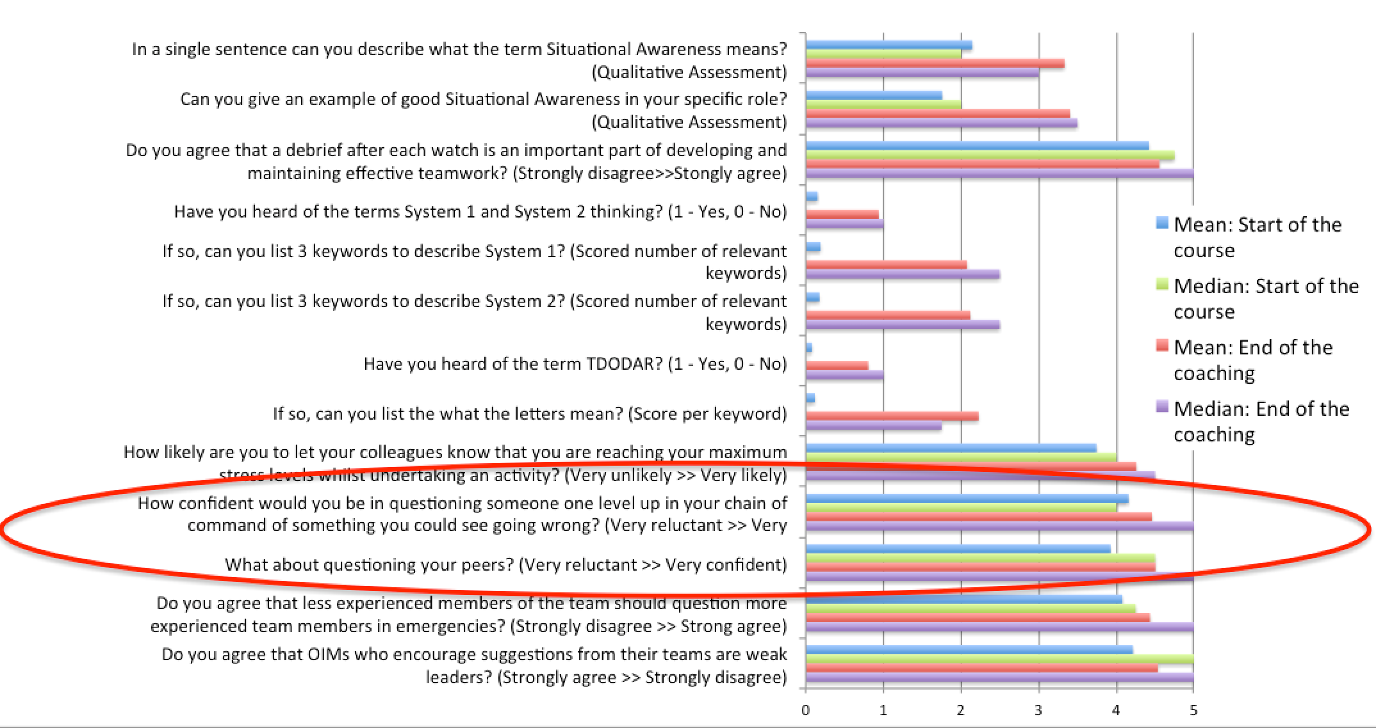
Figure 1. ‘Box ticking’ when assessing assertion skills

The programme ran from October 2014 through to June 2015 and covered four drilling rigs from three contractors, providing more than 1100 hours of training and coaching to 121 supervisors ranging from rig supervisors onshore (training only), DSVs and OIMs to ADs and ACOs. This was achieved by undertaking 4 x 2 week packages per rig to cover the 28:28 shift pattern and four operating crews per rig.

Training

Using the core themes from OGP Report 501, knowledge from working with IOGP and other stakeholders in the creation of IOGP Report 502, oil and gas case studies, using direct experience from other domains including medicine, high threat bomb disposal and commercial aviation, the authors developed a 2-day training intervention inline with the recommendations from IOGP Report 502 and the EI report.

The training was delivered in an onshore classroom environment to minimise distractions and also to allow for the creation and facilitation of practical exercises to reinforce WOCRM themes. Whilst the equipment used to run these exercises could have been taken offshore, the ability to have the crew in a single group undisturbed for 2 days was considered, and demonstrated, to be essential. In fact, trying to deliver ad hoc training in an offshore environment to those who had missed the onshore training conclusively demonstrated why training of this nature in the offshore environment can only be done at a cursory level, even when the DSVs or OIMs try to block off time in their busy operational schedules to complete it. The ad hoc nature also meant that coaching opportunities for those supervisors was limited as the core WOCRM concepts were not yet understood.

Coaching

As shown at Table 1, the key to the success of any training intervention is the need and ability to consolidate that knowledge through the discussion of relevant case studies (Dale, 1969. Flin, R.,et al, 2008. Hopkins, 2012), undertaking practice of the skills and through role-playing.

Presentation | Ability to Recall
 | After 3 hours | After 3 days
Spoken lecture | 25% | 10-20%
Written (reading) | 72% | 10%
Visual and verbal (illustrated lecture) | 80% | 65%
Participatory (role play, case studies, practice) | 90% | 70%
Table 1. Ability to recall information based on presentation type. Adapted from Dale (Dale,1969)

However, it should be noted that while a high level of skill attainment may be achieved through the use of feedback during training, it is only through coaching does a high level knowledge actually get transferred to the job (Joyce & Showers, 1981). As such, undertaking theory training and skills demonstration, and even some skills practice, is unlikely to change behaviours and ultimately achieve results – this refers to Kirkpatrick’s levels 3 and 4 respectively.

Training Components | Skills Attained | Transfer to job
Theory | 10-20% | 5-10%
plus Demonstration | 30-35% | 5-10%
plus Practice | 60-70% | 5-10%
plus Feedback | 70-80% | 10-20%
plus Coaching | 80-90% | 80-90%
Table 2. Skills attained vs transfer to job based on training components. Adapted from Joyce & Showers (Joyce & Showers, 1981)

Consequently, the authors added an additional 6-day offshore coaching period immediately after the training session where the WOCRM instructor & qualified coach flew to the rig with his recently trained supervisors. This coaching consisted of shadowing each supervisor during their role and demonstrating skills (where applicable), providing constructive feedback and coaching advice on their WOCRM skills. Each supervisor received between 12 and 24 hours of coaching (depending on shift size) with coaches working 16-18 hour shifts to provide maximum coaching opportunities across the multiple shift patterns.

It should be noted that to reduce the effects of observer bias or the ‘Hawthorne effect’ (Parsons, 1974) at least four days should be allowed for any initial coaching session to counter this as it took in the order of 3 days for behaviours to return from “suspicious and compliant behaviour” to normal working behaviours. It is only by observing normal behaviours is it possible to see the strengths and weakness of individuals and teams whilst they are working, and thereby provide the opportunity for feedback and subsequent learning. Even with 6 days coaching offshore, the ability to ensure WOCRM skills competency was limited due to multiple shift patterns across the supervisory cadre.

Successes and Challenges

IOGP Report 502 and the EI report, along with the majority of CRM research in the oil and gas industry, is predominately based on Western culture research and practice which infers a relatively coherent culture in terms of language and barriers to communication, crew risk perception and acceptance and core professional skill competencies. However, both documents do mention the need to take into account cultural context, educational background and levels of operational experience of the attendees. This was considered essential for this programme as the crews came from multiple nationalities with sometimes different and conflicting views of safety e.g. the four crews who made up one rig’s complement came from 26 different nationalities. The challenges of diversity have been demonstrated in other areas such as aviation and healthcare, where it has been shown that CRM interventions cannot be easily transplanted from one domain (Catchpole, 2015) or culture (Helmriech et al, 1999. Helmriech & Davies, 2004) to another and therefore differences need to be considered.

In Reports 501, 502 and the EI WOCRM report, reference is made to being aware of the prevailing organisational culture when delivering the training course, modifying content as needed. However, from the author’s experience, this does not go far enough. Even an awareness of the participant’s culture is not going to be enough to effect workplace behavioural change when delivering the training. First, there is need for the trainer/coach to be reflective and understand their own culture and what this means in terms of the WOCRM skills as culture will introduces biases. Secondly, there is a need to understand what culture means to those who are being trained and coached in the intervention. Hofstede (2001), and Trompenaars and Hampden-Turner (1997) explain these processes using cultural models that cover a number of different domains:

- Universalism vs Particularism – Are rules applicable to all, or are there exceptions?
- Individualism vs Communitarism – Partaking in activities for themselves or for the team/community?
- Specific vs Diffuse – ‘Silo’ approach or ‘Holistic’ approach as well as how relationships are developed (long and deep, or fast and shallow)
- Neutral vs Emotional – Public attitudes to showing emotion.
- Achievement vs Ascription – Respect through ‘doing’ or ‘position’/hierarchy.
- Sequential time vs Synchronous time – Parallel or sequential tasking. Time ‘culture’ also impacts attitudes to past/present/future and how they interact.
- Internal or External control – Total control required compared to fatalistic or reactionary attitude.

What is clear from their work, without the supervisor, instructor or coach having an understanding of what their own culture means to them, they will not be able to understand why there is friction or resistance when an intervention is developed and delivered. In essence, because their perspective is different, their proposed solution and its value will likely be different and consequently, potentially ineffective. However, once the culture is clearly understood, the motivational factors for the individuals can be applied more effectively.

As situational awareness (SA) is a factor of experience and skills, the level of SA varied greatly. Nowhere was this greater than demonstrated on two of the rigs where some supervisors had only ever had 15 months of offshore experience. However, at the other end of the scale some had more than 35 years experience. This demonstrated the Dunning-Kruger effect (2003).

The variance of experience and skills across the supervisory cadre, especially in language skills, introduced significant challenges in terms of where to pitch the training to provide maximum benefit, as one size did not fit all. Indeed, the majority of the non-native English speakers were assessed to be A2 - B2, but some of the more junior supervisors and occasional mid-level supervisor were assessed to be C1 and C2 of the Common European Framework of Reference for Languages (Council of Europe, 2001). As such, training, coaching and expectations were modified on a personal basis accordingly. However, there were obvious frustrations observed between native English speaking supervisors and inexperienced non-native English speaking supervisors when relatively simple WOCRM concepts were not being understood in the classroom, even when they were explained at a basic level. Consequently, one-to-one sessions with these supervisors took place to reinforce the WOCRM concepts.

At an individual level, the improvement varied depending on character, language competency and attitude. Some of the supervisors were very enthusiastic and implemented practices such as structured briefs into their daily routine, spending time to personally lead and develop their team members, and changing their questioning technique and communications methods following demonstration, feedback and coaching. Some even became quite reflective, recognising that they had been given new assertion skills and ways of thinking. However, the major change, assessed from both observations and knowledge assessment at the end, was the ability to ‘anticipate’ demonstrating an improvement in their SA, with more ‘what if’ questions being asked by junior supervisors during briefs, demonstrating an improvement in assertion skills and a leadership style that encouraged a more open questioning culture.

This change in behaviour was believed to be informed through the use of formalised briefs and structured debriefs. None of the crews had used a formalized structured brief before, a simple tool that improves team SA, demonstrates communication and leadership skills. In terms of debriefs, these had only previously been considered when things had gone wrong. Indeed, it took some time to convince the crews that the debriefs were there to improve future performance and they should look to focus, in detail, on what made the task progress well, rather than focus on “what did we do wrong?” and looking for someone to blame. This was despite the results from the quiz on day one showing that nearly all respondents thought that a debrief was a good thing to do (Figure 2). Modern safety thinking (Safety I – Safety II) shows that focussing on the negatives in a debrief has less of a performance influence than developing the positives (Dekker, 2012. Hollnagel et al, 2013.)

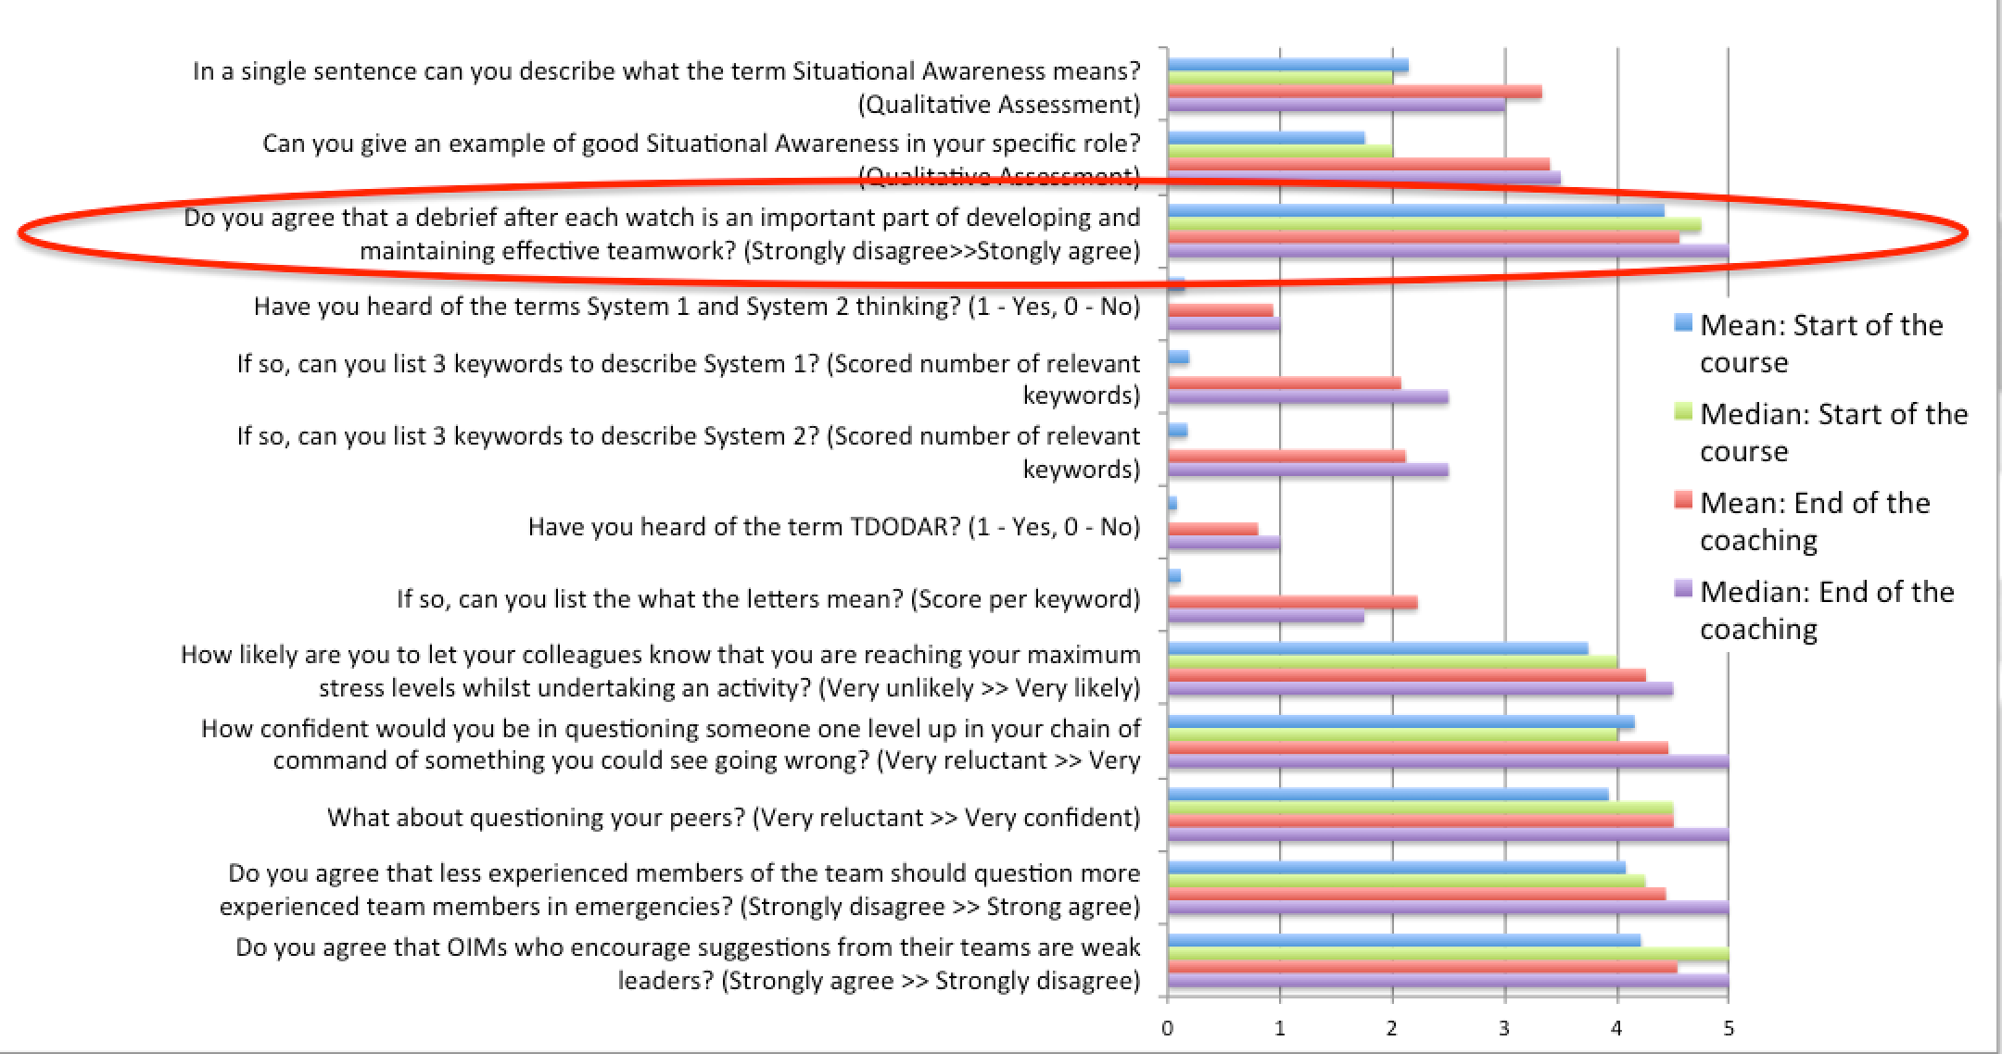
Figure 2. Baseline and end-of-course assessments for all crews

Unfortunately because supervisors had not been taught how to debrief in a positive and constructive manner, this negative response was the norm when coaches prompted a team debrief. Over time the debriefs improved, but it was noted that on two occasions when coaches visited a rig and observed a previously trained crew (due to shift overlap), they needed a prompt to get back to the correct debriefing format. This demonstrates that continued development and leadership is required if interventions, and the subsequent effects, are to be maintained. This is inline with the position presented by Joyce and Showers (1981).

There were a number of comments made during debriefs that the communication, leadership and teamwork skills had been taught before individually, but that given their interdependence they cannot necessarily be treated in isolation. Therefore this coherent programme was appreciated and welcomed, and as a consequence following the delivery of the WOCRM theory, significant gaps in their knowledge were identified. These gaps were closed during subsequent training and coaching.

From feedback obtained at the end of the training sessions, more than 99% of those attending said that the programme was relevant and useful to their role and whilst there is likely to be some biases due to the environment, this can be countered with feedback obtained on the rig after the coaching sessions. Furthermore, there were a number of the supervisors who said that the WOCRM training should be introduced to all crews, albeit tailored for the roustabouts, roughnecks and other support roles, as human factors are equally applicable to them, and in many cases they need to develop assertion and communications skills. This recommendation is stated in both IOGP Report 502 and the EI report.

Measuring the Effectiveness of CRM Interventions

A significant challenge faced by practitioners is the ability to measure the effectiveness of CRM interventions (O’Connor, P. 2002, Salas, E. 2001). CRM itself cannot be measured, only the effects e.g. a comprehensive and effective brief can be observed, but only when the actions briefed are carried out without error, we know that the message was clearly understood. The same can be said about developing SA; if a supervisor has good SA then they are less likely to miss cues and clues of a developing situation and be better prepared for the unexpected. As skills improve, then the likelihood of encountering the effects of poor CRM get less and less. To measure an improvement, it is essential that an assessment of the baseline is undertaken before the recommended WOCRM intervention is introduced.

Finally, WOCRM skills take time to become embedded and habits develop as a consequence, therefore the effects are unlikely to be noticed for a significant period of time. An analogy of going to the gym to lose weight and fat bulk shows this point. After visiting the gym for a week there isn’t a noticeable difference in terms of our body shape and the exercises might actually be harder to complete because our muscles are tired and are not used to the exercise; it is easy to give up at this point. After two weeks the exercises become a little easier but there is still no change to our body shape. After 4 weeks the exercise intensity can be increased, but still no obvious change to our body shape. It isn’t until 3-6 months of regularly going to the gym do we notice the change in our physical appearance. For a change to be adopted, there needs to be a perceived benefit, in the order of 1.5 - 2.5 times the status quo before a change will be started by those involved (Kahneman, 2011).

Conclusions

The positive effects of CRM have been demonstrated in other domains, most noticeably commercial aviation where there is a mandated requirement to undertake regular CRM, and its effectiveness (or lack of) is a core part of post-mission debriefs. This specific WOCRM training and coaching programme achieved positive effects in terms of improved situational awareness through structured briefs and debriefs, amongst other things. However, it also demonstrated that significant long-term commitment and strong leadership is required at all levels if the skills behind WOCRM are to be incorporated into the way “we do things around here”. Finally, those who develop and deploy WOCRM training and coaching interventions cannot take a ‘one size fits all’ approach using a Western culture-based model and simply deploy it into cultures which are significantly different; if they do, then they are likely to encounter resistance and potentially failure.

References

Autrey, T. (2015) 6-Hour Safety Culture: How to Sustainably Reduce Human Error and Risk, (and do what training alone can't (possibly) do). Human Performance Association, Inc.

CAA. (2006) Crew Resource Management (CRM) Training. Guidance for Flight Crew; CRM Instructors (CRMIs) and CRM Instructor- Examiners (CRMI-Es). CAP 737. Version 2. Gatwick: Civil Aviation Authority.

Catchpole, K. R., & Russ, S. (2015). The problem with Checklists. BMJ Quality & Safety. http://doi.org/10.1136/bmjqs-2015- 004431

Catchpole, K. R., Dale, T. J., Hirst, D. G., Smith, J. P., & Giddings, T. A. E. B. (2010). A multicenter trial of aviation-style training for surgical teams. Journal of Patient Safety, 6(3), 180–186.

Council of Europe. (2001). The Common European Framework of Reference for Languages : Learning, Teaching, Assessment. Council of Europe, 1–273. Retrieved from http://www.coe.int/t/dg4/linguistic/CADRE1_EN.asp#TopOfPage

Dale, E. (1969). Audio-visual methods in teaching (Vol. 108). Dryden Press New York.

Dekker, Sidney. (2012). Just Culture : Balancing safety and accountability. Aldershot, England : Ashgate

Energy Institute, (2014). Guidance on Crew Resource Management (CRM), The Energy Institute, London. http://publishing.energyinst.org/__data/assets/file/0010/115120/Sample-pages-Guidance-on-crew-resource-mgmt-CRM...14.07.14.pdf

Flin, R., O’Connor, P., & Crichton, M. (2008) Safety at the sharp end. A guide to non-technical skills. Ashgate

Haynes, A. B., Weiser, T. G., Berry, W. R., Lipsitz, S. R., Breizat, A.-H. S., Dellinger, E. P., … Gawande, A. A. (2009). A Surgical Safety Checklist to Reduce Morbidity and Mortality in a Global Population. New England Journal of Medicine, 360(5), 491–499. http://doi.org/10.1056/NEJMsa0810119

HSE (1999) Reducing Error and Influencing Behaviour. HSG48, London: HSE books.

Helmreich, R. L., Merritt, A. C., & Wilhelm, J. A. (1999). The evolution of crew resource management training in commercial aviation. Int J Aviat Psychol, 9(1), 19–32. http://doi.org/10.1207/s15327108ijap0901_2

Helmreich, R. L., & Davies, J. M. (2004). Culture, threat, and error: lessons from aviation. Canadian Journal of Anesthesia/Journal Canadien D’anesthésie, 51, 1–4.

Hofstede, G. (2001). Culture's Consequences: Comparing Values, Behaviors, Institutions and Organizations Across Nations. 2nd Edition. Thousand Oaks CA: Sage Publications.

Hollnagel, E., Leonhardt, J., Licu, T., & Shorrock, S. (2013). From Safety-I to Safety-II: A White Paper. From Safety-I to Safety-II: A White Paper. Eurocontrol.

Hopkins, A. (2012). Disastrous Decisions: The Human and Organisational Causes of the Gulf of Mexico
Blowout. CCH Australia.

Joyce, B. R., & Showers, B. (1981). Transfer of Training: The contribution of “coaching.” The Journal of Education, 163(2), 163–172. http://doi.org/10.2307/42772926

Kahneman, D. (2011) Thinking, fast and slow. London: Penguin Books, ISBN: 978-0-141-91892-1

Kirkpatrick, D. L. (1976). Evaluation of training. In R. L. Craig (Ed.), Training and development handbook: A guide to human resource development. New York: McGraw Hill. Kirkpatrick,

Kruger, J., & Dunning, D. (1999). Unskilled and unaware of it: how difficulties in recognizing one’s own incompetence lead to inflated self-assessments. Journal of Personality and Social Psychology; Journal of Personality and Social Psychology, 77(6), 1121.

North Sea Offshore Authorities Forum Multi-National Audit (2013) “Human and Organisational Factors in Well Control.”, 1–18. http://www.hse.gov.uk/offshore/nsoaf.pdf

O’Connor, P. (2002). Methods used to evaluate the effectiveness of CRM training: A literature review. Journal of Human Factors and Aerospace Safety.

O’Connor, P. Flin, R. (2003) Crew Resource Management training for offshore oil production teams Safety Science 41 p111-129

OGP (2012). Cognitive Issues Associated with Process Safety and Environmental Incidents. Human Factors Sub-committee, International Associate of Oil and Gas Producers, report No 460, www.ogp.org.uk

OGP (2014). Crew Resource Management for Well Operations Teams. Human Factors Sub-committee, International Associate of Oil and Gas Producers, report No 501, www.ogp.org.uk

IOGP (2014). Well Operations Crew Resource Management Recommended Practice. Human Factors Sub-committee, International Associate of Oil and Gas Producers, report No 502, www.iogp.org.uk

Parsons, H. M. (1974). What Happened at Hawthorne? Science. American Association for the Advancement of Science. http://doi.org/10.1126/science.183.4128.922

Salas, E., Wilson, K. A., Burke, C. S., & Wightman, D. C. (2006). Does crew resource management training work? An update, an extension, and some critical needs. Human Factors: The Journal of the Human Factors and Ergonomics Society, 48(2), 392–412.

Trompenaars F, and Hampden-Turner, C. (1997). Riding the Waves of Culture. 2nd Edition, Boston: Nicholas Brealey.

